PRIOR INDICATIVE NOTICE (PIN)

OPEN TENDER SUMMARY

IO/23/OT/10025818/FMR
For

Construction of B73.5 Shelter

Abstract

The purpose of this summary is to provide prior notification of the IO’s intention to launch a competitive Open Tender process in the coming weeks. This summary provides some basic information about the ITER Organisation, the technical scope for this tender, and details of the tender process for the procurement of the B73.5 Shelter Construction.

Introduction

This Prior Indicative Notice (PIN) is the first step of an Open Tender Procurement Process leading to the award and execution of a Works Contract.

Background

The ITER project is an international research and development project jointly funded by its seven Members being, the European Union (represented by EURATOM), Japan, the People’s Republic of China, India, the Republic of Korea, the Russian Federation and the USA. ITER is being constructed in Europe at St. Paul–Lez-Durance in southern France, which is also the location of the headquarters (HQ) of the ITER Organization (IO).

For a complete description of the ITER Project, covering both organizational and technical aspects of the Project, visit www.iter.org.

The ITER components have started to be delivered to the ITER Site. Some big components named HEL (Highly Exceptional Loads) need to be stored directly onsite protected against the main environmental condition to cope with risk of damage or loss. To address these storage demands, a contract is to be put in place with a qualified Contractor in order to construct a shelter on the ITER Site at short notice. The aim of this shelter is to house large components in storage.

Scope of Services

The scope of this contract is to design, supply and install a covered shelter named B73.5 to be constructed on the north east side of an existing storage building named B73.1 within the ITER. The shelter shall be designed to be usable for at least 5 years.

The Contractor shall install a shelter which shall meet the following minimum requirements:
- Weather tight roof and sides to protect the ITER components in storage against the main climatic risk;
- Compliant with the relevant safety and health regulations applicable in France and Europe;
- The building shall be designed for life of 5years and to withstand the local climatic conditions e.g. snow and wind; and, according to the Eurocodes 0, 1, 3 and 8;
- The shelter shall be adjoined to the B73.1 north façade.

The following size of shelter is expected to be constructed at the ITER Site:
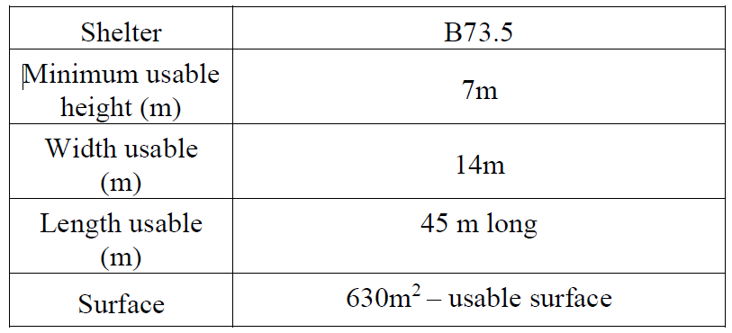

The warehouses shall have free spans, i.e. without intermediate columns inside the building.
The main structure of the building shall be incombustible, fire class A1 and galvanized.

For the full scope of services, please see attached Technical Specifications ref. 8NJ3BQ v1.0

Procurement Process & Objective

The objective is to award a Service Contract through a competitive bidding process.
The Procurement Procedure selected for this tender is called the Open Tender procedure.
The Open Tender procedure is comprised of the following four main steps:
- Step 1- Prior Information Notice (PIN)
The Prior Information Notice is the first stage of the Open Tender process. The IO formally invites interested Suppliers to indicate their interest in the competitive process by returning to the Procurement officer in charge the attached “Expression of Interest and PIN Acknowledgement” by the date indicated under the procurement timetable.
Special attention:
Interested tenderers are kindly requested to register in the IO Ariba e-procurement tool called “IPROC”. You can find all links to proceed along with instruction going to: https://www.iter.org/fr/proc/overview.
When registering in Ariba (IPROC), suppliers are kindly requested to nominate at least one contact person. This contact person will be receiving the notification of publication of the Request for Proposal and will then be able to forward the tender documents to colleagues if deemed necessary.
- Step 2 - Invitation to Tender
After 10 working days of the publication of the PIN, the Request for Proposals (RFP) will be published on our digital tool “Iproc”. This stage allows interested bidders who have indicated their interest to the Procurement Officer in charge AND who have registered in IPROC to receive the notification that the RFP is published. They will then prepare and submit their proposals in accordance with the tender instructions detailed in the RFP.
Only companies registered in this tool will be invited to the tender.
- Step 3 – Tender Evaluation Process
Tenderers proposals will be evaluated by an impartial evaluation committee of the IO. Tenderers must provide details demonstrating their technical compliance to perform the services in line with the technical scope and in accordance with the particular criteria listed in the RFP.
- Step 4 – Contract Award
A Supply contract will be awarded on the basis of best value for money according to the evaluation criteria and methodology described in the RFP.

Procurement Timetable

The tentative timetable is as follows:

Milestone | Date
Publication of the Prior Indicative Notice (PIN) | 14 April 2023
Submission of expression of interest form | 24/04/2023 (10 days after PIN publication)
Invitation to Tender (ITT) launched on iPROC | 25th April 2023
Site Visit placeholder | 10th May (Morning) – to be confirmed
Tender Submission | 13th June 2023
Contract Award | July 2023
Contract Signature | July/August 2023

Quality Assurance Requirements

The Contractor shall have an ITER approved Quality Assurance (QA) Program or an ISO 9001 accredited quality system.

Contract Duration and Execution

The ITER Organization shall award the Works Contract around September 2023. The contract duration shall be 84 calendar days for the works, followed by a Defect Notifications Period of 365 days.
The conditions of Contract that will apply to this procurement is the FIDIC Short Form of Contract, First Edition – 1st edition 1999 (called: Green Book).

Candidature

Participation is open to all legal entities participating either individually or in a grouping/consortium. A legal entity is an individual, company, or organization that has legal rights and obligations and is established within an ITER Member State, being, the European Union (represented by EURATOM), Japan, the People’s Republic of China, India, the Republic of Korea, the Russian Federation and the USA.

Legal entities cannot participate individually or as a consortium partner in more than one application or tender of the same contract. A consortium may be a permanent, legally established grouping, or a grouping which has been constituted informally for a specific tender procedure. All members of a consortium (i.e. the leader and all other members) are jointly and severally liable to the ITER Organization.
In order for a consortium to be acceptable, the individual legal entities included therein shall have nominated a leader with authority to bind each member of the consortium, and this leader shall be authorised to incur liabilities and receive instructions for and on behalf of each member of the consortium.
It is expected that the designated consortium leader will explain the composition of the consortium members in its offer. Following this, the Candidate’s composition must not be modified without notifying the ITER Organization of any changes. Evidence of any such authorisation shall be submitted to the IO in due course in the form of a power of attorney signed by legally authorised signatories of all the consortium members.
All consortium members shall be registered in IPROC.

Sub-contracting Rules

Subcontracting is limited to 30 % of the contract value and up to level 2.
All sub-contractors who will be taken on by the Contractor shall be declared with the tender submission in IPROC. Each sub-contractor will be required to complete and sign forms including technical and administrative information which shall be submitted to the IO by the tenderer as part of its tender.
All declared sub-contractors must be established within an ITER Member State in order to participate.
The IO reserves the right to approve (or disapprove) any sub-contractor which was not notified in the tender and request a copy of the sub-contracting agreement between the tenderer and its subcontractor(s). Rules on sub-contracting are indicated in the RFP itself.

